Assign5a:

//Comments were inherited form the sample code

//I essentially just changed it into a templated format

//Template doesn't work for things such as strings and chars

#include <iostream>

#include <cstdio>

#include <cstdlib>

#include <climits> // For INT_MIN

using namespace std;

template <typename item> //template

class linkedlist

{

public:

struct stack

{

item data;

struct stack* next;

};

int size = 0;

//Function to push a new element in stack.

void push(item element)

{

//Check stack overflow

if (size >= CAPACITY)

{

cout << "Stack Overflow, can't add more element to stack.\n";

return;

}

//Create a new node and push to stack

stack* newNode = new stack;

//Assign data to new node in stack

newNode->data = element;

//Next element after new node should be current top element

newNode->next = top;

//Make sure new node is always at top

top = newNode;

//Increase element count in stack

size++;

cout << "Data pushed to stack.\n";

}

//Function to pop element from top of stack.

item pop()

{

item data = 0;

stack* topNode;

//Check stack underflow

if (size <= 0 || !top)

{

cout << "Stack is empty. \n";

//Throw empty stack error/exception

//Since C does not have concept of exception

//Hence return minimum integer values as error value

//Later in code check if return value is INT_MIN, then

//stack is empty

return INT_MIN;

}

//Copy reference of stack top to some temp variable

//Since we need to delete current stack top and make

//stack top its next element

topNode = top;

//Copy data from stack's top element

data = top->data;

//Move top to its next element

top = top->next;

//Delete the previous top most stack element from memory

free(topNode);

//Decrement stack size

size--;

return data;

}

void display()

{

stack* temp;

for(temp = top; temp != NULL; temp = temp->next)

cout << temp->data << " ";

cout << endl;

}

private:

//private definitions

stack *top = NULL;

int CAPACITY = 1000;

};

int main()

{

//Type definition can only work with definitions such as

//int, float, double, long, short

linkedlist<int> item;

int choice, data;

while(1)

{

//Menu

cout << "------------------------------------\n";

cout << "STACK IMPLEMENTATION PROGRAM\n";

cout << "------------------------------------\n";

cout << "1. Push\n";

cout << "2. Pop\n";

cout << "3. Size\n";

cout << "4. Print the stack\n";

cout << "5. Exit\n";

cout << "------------------------------------\n";

cout << "Enter your choice: ";

cin >> choice;

cout << endl;

switch(choice) //Added overall template definitions (as seen from the item.)

{

case 1:

cout << "Enter data to push into stack: ";

cin >> data;

//Push element to stack

item.push(data);

break;

case 2:

data = item.pop();

//if stack is not empty

if (data != INT_MIN)

cout << "Data pushed = > " << data << endl;

break;

case 3:

cout << "Stack size:" << item.size << endl;

break;

case 4:

item.display();

break;

case 5:

cout << "Exiting from app.\n" << endl;

exit(0);

break;

default:

cout << "Invalid choice, please try again.\n";

}

cout << "\n\n";

}

return 0;

}

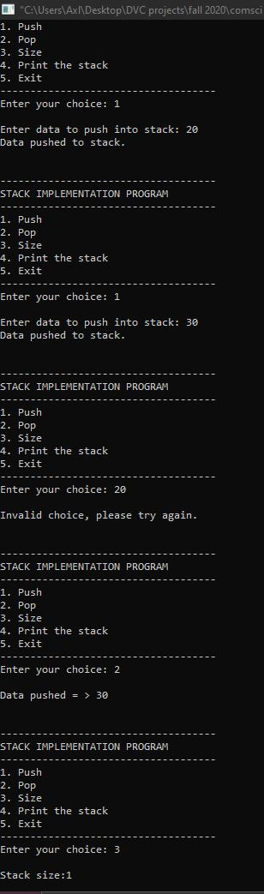

Assign 5b:

/**

Much like the previous case form Assignment 5a, alot of the comments are kept form the actual and sample code as

what I did was merely modification of certain aspects

**/

#include <cstdio>

#include <cstdlib>

#include <climits>

#include <iostream>

#define CAPACITY 100 ///Queue max capacity

using namespace std;

/** Queue structure definition */

template<class item> ///templated structure definition

struct QueueType

{

public:

item data;

struct QueueType * next;

};

/** Queue size */

unsigned int size = 0;

template<class item>

///Class definition

class QType

{

QueueType<item> *front, *rear; ///definition for the front and rear pointers

public:

QType() ///constructor that appoints the pointers to a null value

{

rear = NULL;

front = NULL;

}

int enqueue(int data)

{

QueueType<item> * newNode = NULL;

if (isFull())

{

return 0;

}

newNode = new QueueType<item>;

newNode->data = data;

newNode->next = NULL;

if ( (rear) )

{

rear->next = newNode;

}

rear = newNode;

if ( !( front) )

{

front = rear;

}

size++;

return 1;

}

int dequeue()

{

QueueType<item> *toDequque = NULL;

int data = INT_MIN;

if (isEmpty())

{

return INT_MIN;

}

toDequque = front;

data = toDequque->data;

front = (front)->next;

size--;

free(toDequque);

return data;

}

int getRear()

{

return (isEmpty())

? INT_MIN

: rear->data;

}

int getFront()

{

// Return INT_MIN if queue is empty otherwise front.

return (isEmpty())

? INT_MIN

: front->data;

}

/**

* Checks, if queue is empty or not.

*/

int isEmpty()

{

return (size <= 0);

}

/**

* Checks, if queue is within the maximum queue capacity.

*/

int isFull()

{

return (size > CAPACITY);

}

string prepMenu()

{

string menu = "";

menu+= " \n-------------------------------------------------------------------\n";

menu+= "1.Enqueue 2.Dequeue 3.Size 4.Get Rear 5.Get Front 6.Display 7.Exit\n";

menu+= "----------------------------------------------------------------------\n";

menu+= "Select an option: ";

return menu;

}

void display()

{

for ( QueueType<item> *t = front; t !=NULL; t = t->next)

cout <<t->data << " ";

cout << endl << endl;

}

};

/**

The only changes to the main function between the sample code and this one is that

I have removed the pointer definition for rear and front and moved them to the class

The functions containing rear and front have also had the two removed as it is now part of the class up there

hence not needing any reason to be called again from main.

Functions are also now added with the header call of item. to ensure that they are being called from the class

**/

int main()

{

int option, data;

QType<int> item;

string menu = item.prepMenu();

cout << menu << endl;

cin >> option;

while (option !=7)

{

switch (option)

{

case 1:

cout << "\nEnter data to enqueue (-99 to stop): ";

cin >> data;

while (data != -99)

{

/// Enqueue function returns 1 on success

/// otherwise 0

if (item.enqueue(data))

cout << "Element added to queue.";

else

cout << "Queue is full." << endl;

cout << "\nEnter data to enqueue (-99 to stop): ";

cin >> data;

}

break;

case 2:

data = item.dequeue();

/// on success dequeue returns element removed

/// otherwise returns INT_MIN

if (data == INT_MIN)

cout << "Queue is empty."<< endl;

else

cout << "Data => " << data << endl;

break;

case 3:

/// isEmpty() function returns 1 if queue is emtpy

/// otherwise returns 0

if (item.isEmpty())

cout << "Queue is empty."<< endl;

else

cout << "Queue size => "<< size << endl;

break;

case 4:

data = item.getRear();

if (data == INT_MIN)

cout << "Queue is empty." << endl;

else

cout << "Rear => " << data << endl;

break;

case 5:

data = item.getFront();

if (data == INT_MIN)

cout <<"Queue is empty."<< endl;

else

cout <<"Front => " << data << endl;

break;

case 6:

item.display();

break;

default:

cout <<"Invalid choice, please input number between (0-5).\n";

break;

}

cout <<"\n\n";

cout << menu<< endl;

cin >> option;

}

}

